# Abstract

[To start again on]

# Structure

## Introduction

This paper describes a simulation-based approach for mapping utility scores reported for a larger number of states onto a smaller number of states, where the frequency of patients in each outcome state is also reported. The method is essentially a data reduction technique that involves simulated data reconstitution as an intermediate stage.

We show two related examples where our method is useful when building and populating health economic models. Firstly, we show how the approach is used for estimating utility multipliers associated with being in an independent or dependent state following a stroke, given utility estimates and proportions reported recently in MDM by Modified Rankin Scale (mRS), which has seven mutually exclusive stroke severity states. (1) Secondly, we show how the approach can be extended to produce estimates for the mean utility values associated with states on the Glasgow Outcome Scale for traumatic brain injuries. Both examples make use of the data reported in the MDM paper reporting mRS outcomes, but involve collapsing the seven states into three states in the first example, and four states in the second example. The method described was developed when trying to build a model of the consequences of prescribing oral anticoagulants (OACs) in the management of atrial fibrillation (AF), OACs reduce stroke risk but can lead to intracranial haemorrhages which can cause brain injury leading to qualitatively similar types and degrees of disablement to the strokes which they are intended to prevent. It is for this reason that it was considered advantageous to use utility estimates based on the same group of patients.

## Method

### Information required

In order to use the approach described here, we need two sorts of information, and to make one assumption. The first type of information we need is the mean utilities associated with each of the larger number of states (mRS states in this paper). The second type of information we need is on the distribution of patients in each of these categories. Then, we need to be able to state an assumption about how the larger number of categories (mRS states in our examples) relate to the smaller number of categories (independent/dependent states, and GOS states, in our examples). In our examples, the first two pieces of information were provided in a previous paper published in MDM in 2010, which we refer to as our ‘source paper’.(1)

### The Modified Rankin Scale (mRS)

The mRS is a commonly used measure of disability or dependence in daily activities following a stroke. It was introduced in its current form by van Swieten et al in 1988(2), and originally based on a 1957 paper by J Rankin.(3) The mRS is a seven level ordinal scale, with scores ranging from 0-6 inclusive, and has good inter-rater reliability.(4)

### The source paper

The paper we used as a data source for our approach was published in MDM in 2010 and used data from the Oxford Vascular Study (OXVASC).(1) OXVASC is a large scale population-based cohort, initiated in 2002, involving almost 100,000 individuals registered in Oxfordshire.(5) The source paper used 1283 patients from this study, recruited between April 2002 and March 2007, who had suffered either stroke or transient ischemic attack (TIA). These patients were followed-up for up to 24 months following the stroke. The patients’ condition was assessed using the disease specific measure of the mRS, as well as the generic utility instrument EQ-5D. Based on this, the EQ-5D utilities associated with each state were estimated and reported. (1)

The source paper reported that, of the 1,283 patients who had a stroke within the Oxford vascular study (OXVASc) cohort, 24.8% (319 / 1,283) were dead within 24 months. Of those who survived, mRS scores following the stroke was graded according to the modified Rankin Scale (mRS) 24 months after the event in 425 patients.(1) For simplicity this 24 month state is assumed to be the patient’s long-term condition, and the patients for whom mRS outcomes were reported were assumed to be representative of those for whom the data were not collected. The ordinary least squares (OLS) based mean estimates for the utility associated with each state, combined with the standard deviations around these mean estimates, were also reported.

### Category mapping assumptions made

In each of the examples presented in this paper, different categorisation assumptions were made about how each of the mRS categories mapped onto a smaller number of categories. The correspondences assumed are shown in Table 1 below. For the first example, we adopted the standard assumption that an independent stroke outcome corresponds to an mRS state 0, 1 or 2, and that a dependent stroke outcome corresponds to an mRS state 3, 4, and 5. Death is mRS state 6, and was assumed throughout to have a utility and utility multiplier value of 0.

In the second example, we looked at the verbal descriptions of each of the mRS states, and each of the GOS states, and from this made the assumption that GOS 5 (‘good recovery’) corresponds to mRS states 0 or 1, that GOS 4 (‘moderately disabled’) corresponds to mRS states 2 or 3, and that GOS 3 (‘severely disabled’) corresponds to mRS states 4 or 5. GOS 2 (‘persistent vegetative state’) was assumed to have no utility, and so correspond, alongside GOS 1 (‘dead’) with mRS 6 (‘dead’).

### Graphical representations of the method

Figure 1 shows how the method has been applied in the first example, where the aim is to map the mRS states onto the three mutually exclusive states of ‘independent stroke’, ‘dependent stroke’ and ‘dead’. Figure 2 shows the equivalent method for mapping from the mRS states to the GOS states. As the figures show, the approaches are identical apart from the final stages, where mRS state information are combined in different ways. For this reason the stages which are common to both examples will be described first.

### Simulating proportions in each mRS state

The proportions in each of the mRS states at 24 months, which was assumed to be the long-term outcome, were simulated in a two stage process using data from table 1 of the source paper. In the first stage (Node 1 in both and ) the proportion that dies as a result of suffering a stroke is first simulated using a binomial distribution. In the second stage (Node 2a in both and ), the distribution of those alive in each of the six living mRS states (mRS categories 0 to 5) was simulated using a Dirichlet distribution, using cell counts from table 1 of the source paper at 24 months as input parameters. These simulated proportions were then stored for later use (Node 3a in both and ). The R code for doing this is:

mRS_followingStroke <- rdirichlet(N.PSA, c(61, 143, 111, 82, 24, 4))

Where N.PSA and c(61, 143, 111, 82, 24, 4) are both arguments to the rdirichlet function. N.PSA provides the number of PSA samples to produce, and c(61, 143, 111, 82, 24, 4) providing the parameter values for the Dirichlet function. These parameter values are taken directly from table 1 of the source paper.

### Simulating utilities associated with each mRS state

Table 3 of the source paper presents mean EQ-5D utility values and standard errors associated with each mRS state. These values were used to produce a large number of simulated values of the mean values of the utility of each state, by assuming that the utility estimates each followed a normal distribution. This process allows parameter uncertainty at this stage to be propagated through to later stages rather than disregarded. The R code for doing this for the mRS 3 state is:

s3 <- rnorm(N.PSA, .545, .277)

Where 0.545 is the mean utility reported in table 3 of the source paper for this mRS state, and 0.277 is the standard error reported. The simulated values for the other mRS states are produced similarly.

### Converting simulated utility values into utility multipliers

In the economic model we developed, utility multipliers rather than utility values themselves were used [reason why we did this]. To turn the utility simulations into utility multipliers (indicated in node 5 of both and ) we assumed that mRS 0 (‘no symptoms’) represented full health. The multipliers for mRS states 1-5 were therefore produced by dividing simulated values from the more severe category by simulated values from the mRS 0 distribution. Because R is a vector based language, the command for producing the utility multiplier associated with mRS 3, for example, is simply:

mult.s3 <- s3/s0

This produces a vector of length N.PSA, because both s3 and s0 are also vectors of length N.PSA. The multipliers associated with the other mRS states are produced similarly. Producing utility multipliers in this way means that uncertainty in both the numerator and denominator values are incorporated in the simulation.

### Simulating relative proportions of mRS states in each of the collapsed states

Within the first example, illustrated in , the independent state category (Node 4a) is comprised of the three component states mRS 0, mRS 1 and mRS 2, and the dependent state category is comprised of the three component states mRS 3, mRS 4 and mRS 5. However, neither the independent state category nor the dependent state categories are composed of equal amounts of each component state, and so an equal weighting should not be assumed. It would also be wrong to disregard parameter uncertainty due to the finite sample size on which these estimates are based. To address both of these concerns, the component states were dynamically reweighted in the collapsed states for each of the Dirichlet draws produced and stored previously (Nodes 2a and 3a of ). This process is illustrated graphically for a single draw from the Dirichlet distribution in Figure 3.

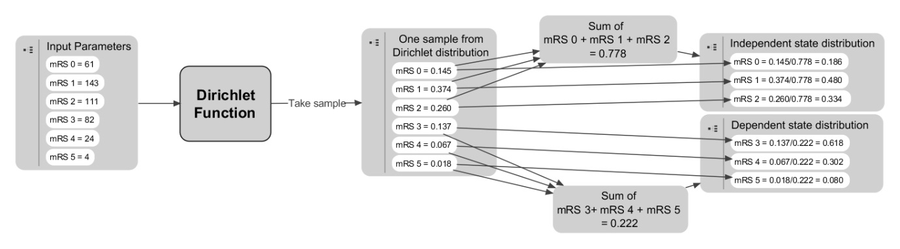

Figure 3 Weighting the component states in the collapsed states (dependent state, independent state) based on a draw from the Dirichlet distribution

Within R the code for doing this for each draw from the Dirichlet distribution for the Independent state category is shown below:

Stroke.Ind <- mRS_followingStroke[,1:3]

Stroke.Ind.sums <- apply(Stroke.Ind, 1, sum)

Stroke.Ind <- apply(Stroke.Ind, 2, function (x) x / Stroke.Ind.sums)

The approach for the Dependent stroke category is similar, but uses columns 4, 5 and 6 of the object mRS_followingStroke, instead of columns 1, 2 and 3.

### Producing weighted utility multiplier estimates for independent and dependent stroke categories

Estimates of the relative proportion of each of the component mRS states in the collapsed states (Nodes 4a and 4b of ), and of the utility multipliers associated with each of the component states, were combined to produce simulated distributions of the utility multipliers associated with Independent and Dependent stroke states. For the Independent state the R code for doing this is as follows:

Stroke.Ind.utils <- Stroke.Ind[,1] * 1 + Stroke.Ind[,2] * mult.s1 + Stroke.Ind[,3] * mult.s2

Here Stroke.Ind[,1] refers to the first column, the weight of mRS 0, and Stroke.Ind[,1] refers to column 2, the corresponding weights of mRS 1. The object mult.s1 is a vector of estimates of the utility multiplier of mRS 1 compared with mRS 0, and mult.s1 is a vector of estimates of the utility multiplier of mRS 2 compared with mRS 0. As the reference utility value is mRS 0, the utility multiplier associated with mRS 0 is just 1. The weighted utility multiplier estimates associated with Dependent strokes are calculated similarly.

### Bootstrapping means from the collapsed distributions

The weighted utilities produced at the previous iteration involve weighted mixtures of three component distributions, which as multipliers are each derived from the ratio of two distributions. The variance of these component distributions are affected by the variances of the standard errors reported in the source paper, which in turn depend on the number of observations at each mRS state. An implication of this is that, as the number of people in the most severe live mRS state, mRS 5, is very small, the variance of the associated mRS 5 multiplier is very wide. Without further processing of these results, an implication of this is that some PSA estimates for the Dependent State may be higher than for the Independent state, and contain other implausible values such as those significantly below zero of above one, simply due to the high level of variance of the component distribution. In order to ensure that the process described produces plausible estimates, bootstrapped estimates of the means of the collapsed distributions, rather than the distributions themselves, were used within the PSA.

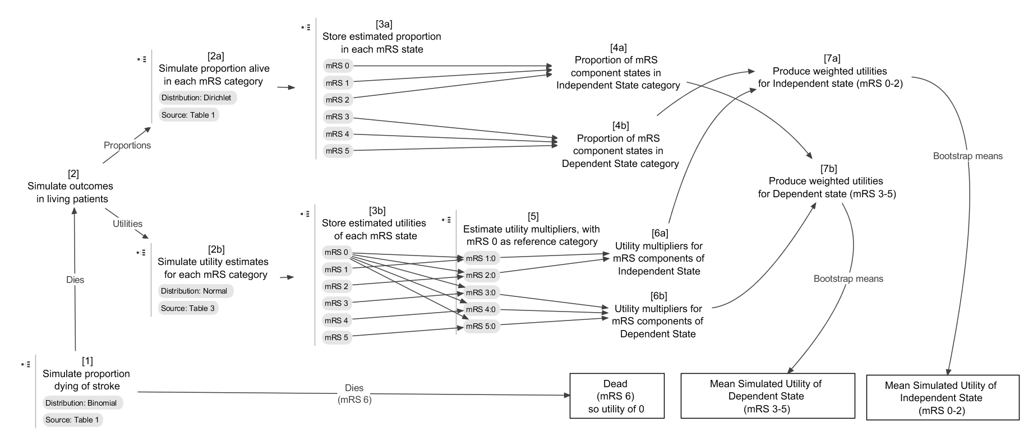

Figure 1 Graphical representation of approach for mapping from mRS states to dependent stroke and independent stroke states. (Sources refer to sources in Rivero-Arias).

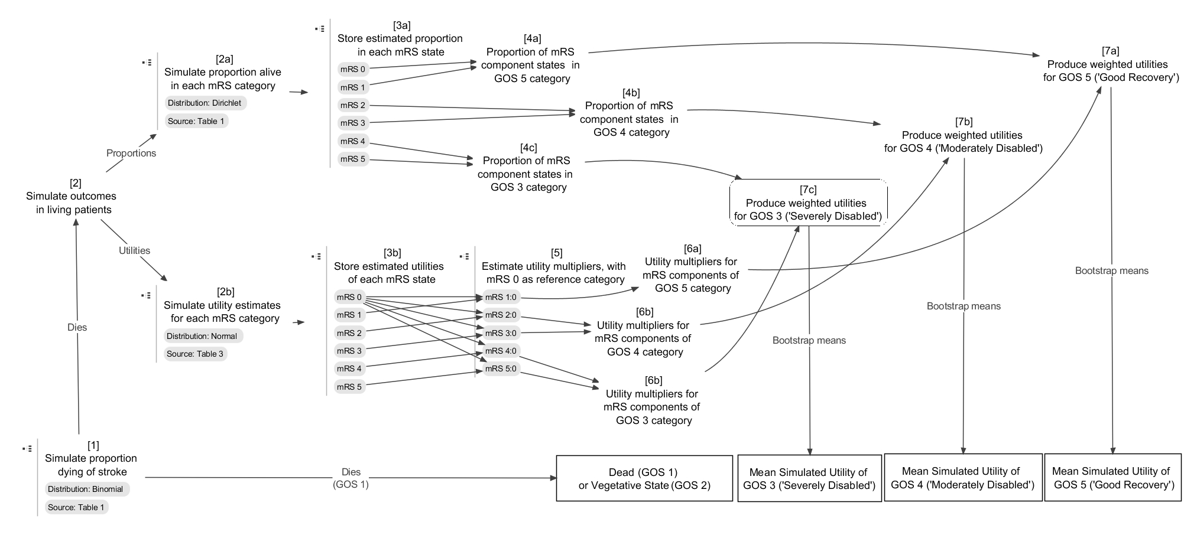

Figure 2 Graphical representation of approach for mapping from mRS states to GOS states

## Results

The following section shows first the simulated proportion and mean simulated utility in the three state example (dead, independent state, and dependent state) and the GOS example.

### Results for three state simulation

Table 1 below shows the mean simulated proportions in the dead, independent and dependent stroke state, together with 95% credible intervals (95% CrIs) as well as mean simulated utility multipliers associated with each of the states, also with 95% CrIs. The simulation suggests that approximately one quarter of patients die as a result of a stroke, around one fifth are left in a dependent state, and the remainder are left in an independent state. Being in a dependent state leads, on average, to slightly more than a halving of the patient’s quality of life, whereas being in an independent state leads to quality of live reducing by around one fifth.

|  |  |  |
| --- | --- | --- |
|  | Proportion  Mean (95% CrIs) | Utility Multiplier  Mean (95% CrIs) |
| Dead | 0.249 (0.225 to 0.273) | 0 |
| Independent | 0.557 (0.520 to 0.592) | 0.823 (0.821 to 0.826) |
| Dependent | 0.194 (0.164 to 0.228) | 0.483 (0.478 to 0.487) |

Table 1 Mean simulated proportions dead, or in dependent state or independent state following a stroke, together with 95% credible intervals

### Results for GOS simulation

The utility multipliers associated with different GOS states, based on the simulation approach described above, are shown in Table 2 below.

|  |  |
| --- | --- |
| State | Utility Multiplier  Mean (95% CrIs) |
| GOS 1: Dead  Or  GOS 2: Vegetative State | 0 |
| GOS 3: Severely Disabled | 0.226 ( 0.221 to 0.231) |
| GOS 4: Moderately Disabled | 0.642 (0.638 to 0.645) |
| GOS 5: Good Recovery | 0.895 (0.892 to 0.898) |

Table 2 Mean utility multipliers associated with different GOS states

### Summary

[to complete, depending on what to do with 2nd example]

## Discussion

### Key findings

This paper shows how a simulation-based approach can be used to collapse costs or utility values from a larger to a smaller number of discrete states in a way which incorporates uncertainty at the intermediate stages. This means that the estimates produced are replicable and involve a minimum of modeller assumptions being made. All that is required are the sample sizes and utility estimates of the uncollapsed states, and a belief about how the uncollapsed states map onto the collapsed states. Because of this, it is possible to make use of more recent and /or more pertinent data to inform the economic model than was previously possible using summary data alone. The approach involves making a number of assumptions, but these assumptions are clearly stated and can be developed and improved upon where additional clinical and statistical data allow it. These are discussed in more detail in the implications for research section below. In the case studies provided the approach was shown to be able to make use of the same population to inform both the utility consequences of strokes, and the utility consequences of intracranial haemorrhages which may result from prescribing oral anticoagulants to try to present strokes, allowing a model based on such data some level of greater consistency. The approach can be applied to other similar situations, provided the right form of summary data exist, which report the frequency of patients in different states, as well as the utilities associated with each state.

### Para 2: Possible mechanisms and explanations for the findings

### Para 3: Compare study results with relevant findings from other published work

For our main example, our estimated utility multipliers are very similar to those presented in Dorman et al.,(6) for independent strokes but somewhat higher than those reported in that paper for dependent strokes. This is largely due to the distribution of mRS states within the Independent Stroke and Dependent Stroke categories, which for both categories of stroke are weighted towards less severe mRS states. In the case of dependent strokes (mRS 3-5), for example, only around 4% were the worst category mRS 5, which has an estimated EQ-5D score around zero, and around 75% were in the least worst category mRS 3, which has an estimated EQ-5D score over 0.5. The discrepancy may reflect improvements in the prognosis following strokes in the decade that separates the studies used. This highlights the importance of making use of more recent data where possible, given that healthcare systems change and improve; to do otherwise may be misrepresenting the costs and clinical consequences of modern treatment regimens for particular conditions.

### Limitations

(IN EQ5-D some vegetative states are valued at less than zero !)

The approach described here cannot be expected to produce perfect estimates of costs and utilities associated with outcomes. Instead the aim is to make better use of existing summary data. Without individual level data reporting all outcomes of interest in terms of costs and utilities in the same population, there will always be errors and biases associated with the estimates. There are reasons to expect that the simulation approach described here will be better than alternative approaches in some situations but not others. For example, in our stroke case study, data were available in the required number of states that were relatively old, and in more states based on much more recent data. The older data estimates were based on an individual patient level analysis ~~of the older data~~, whereas the more recent estimates produced here were based on a reconstruction of summaries of newer data. The additional assumptions required to produce the simulation introduce additional sources of potential error and bias into the estimates, but on the other hand allow use of a dataset which may be much more pertinent to the decision problems of interest. The decision whether to base the estimates on older or less pertinent data without making additional assumptions ~~implicit here~~, or to use the simulation approach described here and make use of more pertinent data, is a matter of modeller judgment which should be informed by a clinical understanding of the subject area.

Assumptions involved in producing the simulations include: the need to assume perfect mapping (or deterministic ‘bijection’) between health states based on descriptions of states and the choice of normal distributions as the distributions to simulate from. In both cases, alternative assumptions could be made, and, where they are not the fact, these assumptions is made explicit ??? grammar? and open to further investigation.

The bijection assumption should represent the best assumption of the economic modeller based on clinical knowledge, and where other clinical evidence and opinion exists which suggests alternative mapping arrangements should be considered or used instead, the effect of making these assumptions on the modelling results and utility/cost estimates should be explored and presented where possible.

The effect of using a normal distribution, and the other choices of distribution indicated in this paper ? which ones ?, should also be explored, and the effect of these assumptions on the estimates made explicit.

It is known, for example, that the normal distribution is not bounded between any two particular values, whereas the EQ-5D utility values which are mapped onto the mRS states are known to be bounded between approximately -0.54 and 1 for the UK value Tables[ REF] (it differs in other countries) . Where the values from the simulation fall outside these limits, it may be appropriate to resample from the distribution, or to consider the use of alternative distributions for representing these limits ~~variation~~.

PS: it is difficult to find a distribution that fits boths limits as the beta distribution is strictly positive between 0-1 and has zero mass at 0, truncated normal may be tried instead or else a mix of distributions could be used (one for values of 1- not1, and a second for values between -0.54 and up to 1, etc….. but to my awareness few of these alternatives have been tested.

In terms of the source data used, it is known that EQ-5D data are only poorly approximated by the Normal distribution, as the distribution of EQ-5D is typically known to be ‘multimodal’. This represents a more general limitation common to a range of modelling approaches, rather than something specific to this approach.

Due to a paucity of information to suggest otherwise, a number of assumptions had to be made in the case studies discussed. For example, the 24 month state reported in the Rivero-Arias paper was assumed to be the patient’s permanent state until another event occurs, and the patients for whom mRS outcomes were reported were assumed to be representative of those for whom the data were not collected. Additionally, it was assumed that all patients who died of strokes died instantly, which will underestimate both the costs and utilities associated with this event. There are also potential issues of generalisability when applying estimates based on a sample of the OXVASc study population to other patient populations, especially if adapting models based on these estimates to other countries. (That is always the case both ofr clinical and cost data)

### Research recommendations

A range of further research directions are possible based on this approach. The most important of these is to attempt to verify the accuracy of this approach using individual patient data where the true answers are already known. The comparison presented in this paper was unable to do that because the results were based on different studies. Research should also be conducted to try to identify the most appropriate way of applying this form of approach to a range of clinical areas, including the most appropriate choice of distributions and bijection assumptions to make.

The main purpose of the approach described here is to make sure that decision models are based on all pertinent available information, and are not limited by lack of clear interoperability between costs and utility summaries. The effectiveness of this approach should be judged on whether it offers an improvement on current practice, rather than whether it produced the most accurate summary estimates theoretically possible.

In the clinical area considered in the case study, it may also be valuable to see how the model could be applied to summary data which report either mean cost or utility data using the Barthel index, which is also commonly used in this area. (6–8)

If mapping from either ( that is ?) categorisation system to the same categorisation system yields similar results when based on the same or similar population, (rather convoluted sentence No?) then this would provide further evidence in support of the validity of the approach described here.

### Conclusions

The implications for clinical practice of this research are subtle, but have the potential to be significant. The choice of cost and utility estimates in cost effectiveness models affects the results they produce, which in turn has the potential to affect the decisions made by healthcare reimbursement agencies like NICE, and so the range and quality of the healthcare experienced by patients. An implication of this model for cost-effectiveness models is that, if the modeller chooses to accept the limitations of the method used to produce them, a newer set of utility multiplier estimates are available to modellers using mathematical models which involve strokes and different stroke categories as health states. The approach described also could be adapted to other datasets in other clinical areas. The validity and attractiveness of this approach in comparison to the alternatives needs further investigation and consideration.

## Appendix

|  |  |
| --- | --- |
| **R code** | **Comments** |
| Bootstrapper <- function(inputs, simulates = 10000){  X.mean <- vector("numeric", simulates)  N.inputs <- length(inputs)  for (i in 1:simulates) {X.mean[i] <- mean(inputs[sample(1:N.inputs, replace=T)])}  return(X.mean)  }  Require(MCMCpack)  N.PSA <- 10000  Dead_nonDead <- rbinom(N.PSA, 1283, (319/1283)) / 1283  mRS_followingStroke <- rdirichlet(N.PSA, c(61, 143, 111, 82, 24, 4))  DepInd_followingStroke <- cbind(apply(mRS_followingStroke[,1:3], 1, sum), apply(mRS_followingStroke[,4:6], 1, sum))  DeadDepInd_followingStroke <- cbind(Dead_nonDead, (1 - Dead_nonDead) * DepInd_followingStroke[,1], (1-Dead_nonDead) * DepInd_followingStroke[,2])  colnames(DeadDepInd_followingStroke) <- c("Dead", "Independent", "Dependent")  s0 <- rnorm(N.PSA, .959, .074)  s1 <- rnorm(N.PSA, .812 , .181)  s2 <- rnorm(N.PSA, .656, .218)  s3 <- rnorm(N.PSA, .545, .277)  s4 <- rnorm(N.PSA, .248, .281)  s5 <- rnorm(N.PSA, .020, .046)  mult.s1 <- s1/s0  mult.s2 <- s2/s0  mult.s3 <- s3/s0  mult.s4 <- s4/s0  mult.s5 <- s5/s0  Stroke.Ind <- mRS_followingStroke[,1:3]  Stroke.Dep <- mRS_followingStroke[,4:6]  Stroke.Dep.sums <- apply(Stroke.Dep, 1, sum)  Stroke.Ind.sums <- apply(Stroke.Ind, 1, sum)  Stroke.Dep <- apply(Stroke.Dep, 2, function (x) x / Stroke.Dep.sums)  Stroke.Ind <- apply(Stroke.Ind, 2, function (x) x / Stroke.Ind.sums)  Stroke.Ind.utils <- Stroke.Ind[,1] * 1 + Stroke.Ind[,2] * mult.s1 + Stroke.Ind[,3] * mult.s2  Stroke.Dep.utils <- Stroke.Dep[,1] * mult.s3 + Stroke.Dep[,2] * mult.s4 + Stroke.Dep[,3] * mult.s5  Stroke.Ind.utils.mean <- Bootstrapper(Stroke.Ind.utils)  Stroke.Dep.utils.mean <- Bootstrapper(Stroke.Dep.utils) | This is code for a bespoke function in R for finding the bootstrapped means of a vector of numbers. Other bootstrapping functions exist, but this function is easy to make.  The function defaults to running 10,000 bootstraps of the dataset. This can be adjusted by specifying a different ‘simulates’ argument.  Loads a library containing the rdirichlet() function used later.  Specify that PSA involves 10,000 sets of draws  **NODE 1**  Specifies that the object Dead_nonDead should be created containing 10,000 draws from a binomial distribution.  The binomial distribution is parameterized with two numbers from table 1 of Rivero-Arias. ‘319’ is the number dead following stroke. ‘1283’ is the sample size of relevant individuals. The outputs from rbinom are all divided by 1283 to produce proportions rather than frequencies.  **NODE 2a + NODE 3A**  This creates a matrix containing the output of 10,000 draws from a dirichlet distribution populated by the values from table 1 of the Rivero-Arias paper showing distribution of modified Rankin Scale stroke outcomes at 24 months.  **NODE 4a + NODE 4b**  This converts six columns of mRS_followingStroke into two columns, giving the sums of ‘independent’ and ‘dependent’ strokes respectively. The two calls to the apply function take the first three and last three columns of the mRS_followingStroke dataframe, and output the sums of each row.  This combines estimates of the proportion alive following a stroke, Dead_nonDead, with the proportion of those alive in either dependent or independent states, DepInd_followingStroke. The output is a three column matrix giving 1) proportion alive; 2) proportion in independent state; 3) proportion in dependent state.  This command labels the columns of the previously created matrix to be easier to interpret.  **NODE 2b + NODE 3b**  These commands use data from table 3 (the 24 months column) from Rivero-Arias to produce 10,000 draws from Normal distributions parameterized with the means and standard error values from the paper. s0 is the estimated utility following an mRS 0 outcome, s1 is the estimated utility following an mRS 1 outcome, and so on.  **NODE 5 + NODE 6a + NODE 7a**  These convert the draws of estimates associated with each of the mRS states into utility multipliers for each of states mRS 1 to 5, where mRS 0 is the reference category.  **NODE 4a + NODE 4b**  These commands calculate the relative distribution of mRS states among those within either the ‘dependent’ (mRS 3-5) in ‘independent’ (mRS 0-2) stroke categories.  This allows weighted averages of utilities from mRS specific utility multipliers to be produced later.  **NODE 7a**  This produces an estimate of the utility multiplier associated with an independent stroke using a weighted average of utility multipliers associated with mRS 0, mRS 1 and mRS 2  **NODE 7b**  This produces an estimate of the utility multiplier associated with a dependent stroke using a weighted average of utility multipliers associated with mRS states 3, 4 and 5.  **BOOTSTRAPPING**  These commands run the bootstrapping function created earlier to produce 10,000 bootstrapped estimates of the centre of the distributions Stroke.Dep.utils and Stroke.Ind.utils. |
| **R code** | **Comments** |
| GOS_5 <- mRS_followingStroke[,1:2]  GOS_4 <- mRS_followingStroke[,3:4]  GOS_3 <- mRS_followingStroke[,5:6]  GOS_5.sums <- apply(GOS_5, 1, sum)  GOS_4.sums <- apply(GOS_4, 1, sum)  GOS_3.sums <- apply(GOS_3, 1, sum)  GOS_5 <- apply(GOS_5, 2, function (x) x / GOS_5.sums)  GOS_4 <- apply(GOS_4, 2, function (x) x / GOS_4.sums)  GOS_3 <- apply(GOS_3, 2, function (x) x / GOS_3.sums)  GOS_5.utils <- GOS_5[,1] * 1 + GOS_5[,2] * mult.s1  GOS_4.utils <- GOS_4[,1] * mult.s2 + GOS_4[,2] * mult.s3  GOS_3.utils <- GOS_3[,1] * mult.s4 + GOS_3[,2] * mult.s5  n.bootstraps <- 10000  GOS_5.mean <- vector("numeric", n.bootstraps)  GOS_4.mean <- vector("numeric", n.bootstraps)  GOS_3.mean <- vector("numeric", n.bootstraps)  for (i in 1:n.bootstraps){  GOS_5.mean[i] <- mean(GOS_5.utils[sample(1:N.PSA, n.bootstraps, replace=T)])  GOS_4.mean[i] <- mean(GOS_4.utils[sample(1:N.PSA, n.bootstraps, replace=T)])  GOS_3.mean[i] <- mean(GOS_3.utils[sample(1:N.PSA, n.bootstraps, replace=T)])  } | Approach for mapping from mRS to GOS  Assuming code above has all been run (so mRS estimates and so on have all been calculated)  **NODE 4a + NOD 4b + NODE 4c**  These commands the Dirichlet derived cell counts into GOS 5 (columns 1 and 2), GOS 4 (columns 3 and 4), and GOS 3 (columns 5 and 6).  These commands calculate the sums across the rows of the newly created variables GOS_5, GOS_4, and GOS_3  These commands convert the cell counts into proportions.  **NODE 6a + NODE 6b + NODE 6c + NODE 7a + NODE 7b + NODE 7c**  These commands calculate a weighted utility multiplier value for each row in GOS_5, GOS_4 and GOS_3 given the relative proportion of each of the component states.  **BOOTSTRAPPING**  *These commands show how to perform bootstrapping without use of the Bootstrapper function developed earlier*  Sets the number of bootstrap replicates to 10,000  Creates three empty vectors for storing bootstrapped estimates of the means  Produces 10,000 bootstrapped estimates of the means of GOS_5, GOS_4 and GOS_3 |

# References

1. Rivero-Arias O, Ouellet M, Gray A, Wolstenholme J, Rothwell PM, Luengo-Fernandez R. Mapping the Modified Rankin Scale (mRS) Measurement into the Generic EuroQol (EQ-5D) Health Outcome. Medical Decision Making [Internet]. 2010;30(3):341–54. Available from: <Go to ISI>://000277892800009

2. van Swieten JC, Koudstaal PJ, Visser MC, Schouten HJ, van Gijn J. Interobserver agreement for the assessment of handicap in stroke patients. Stroke [Internet]. 1988 May 1 [cited 2012 Mar 18];19(5):604–7. Available from: http://stroke.ahajournals.org/cgi/doi/10.1161/01.STR.19.5.604

3. RANKIN J. Cerebral vascular accidents in patients over the age of 60. II. Prognosis. Scottish medical journal [Internet]. 1957 May [cited 2012 Apr 4];2(5):200–15. Available from: http://www.ncbi.nlm.nih.gov/pubmed/13432835

4. Wilson JTL, Hareendran A, Hendry A, Potter J, Bone I, Muir KW. Reliability of the modified Rankin Scale across multiple raters: benefits of a structured interview. Stroke; a journal of cerebral circulation [Internet]. 2005 Apr [cited 2012 Apr 4];36(4):777–81. Available from: http://www.ncbi.nlm.nih.gov/pubmed/15718510

5. Rothwell PM, Coull AJ, Giles MF, Howard SC, Silver LE, Bull LM, et al. Change in stroke incidence, mortality, case-fatality, severity, and risk factors in Oxfordshire, UK from 1981 to 2004 (Oxford Vascular Study). Lancet [Internet]. 2004 Jun 12 [cited 2012 Sep 28];363(9425):1925–33. Available from: http://www.ncbi.nlm.nih.gov/pubmed/15194251

6. Dorman P, Dennis M, Sandercock P. Are the modified “simple questions” a valid and reliable measure of health related quality of life after stroke? Journal of Neurology, Neurosurgery & Psychiatry [Internet]. 2000;69(4):487–93. Available from: http://jnnp.bmj.com/content/69/4/487.abstract

7. Lin H-J, Wolf PA, Kelly-Hayes M, Beiser AS, Kase CS, Benjamin EJ, et al. Stroke Severity in Atrial Fibrillation: The Framingham Study. Stroke [Internet]. 1996;27(10):1760–4. Available from: http://stroke.ahajournals.org/content/27/10/1760.abstract

8. Sandercock P, Berge E, Dennis M, Forbes J, Hand P, Kwan J, et al. A systematic review of the effectiveness, cost-effectiveness and barriers to implementation of thrombolytic and neuroprotective therapy for acute ischaemic stroke in the NHS. Health Technology Assessment. 2002;6(26).

Tables

|  |  |  |  |  |
| --- | --- | --- | --- | --- |
| **mRS Score** | **Category** | **Description** | **Reduced Category** | **Glasgow Outcome Scale State** |
| 0 | No Symptoms | No symptoms at all. | Independent stroke | GOS 5: Good Recovery |
| 1 | No Significant Disability | No significant disability despite symptoms; able to perform all usual duties and activities. |
| 2 | Slight Disability | Slight disability; unable to perform all normal activities but able to look after own affairs without assistance | GOS 4: Moderately disabled |
| 3 | Moderate Disability | Moderate disability requiring some help but able to walk without assistance. | Dependent stroke |
| 4 | Moderately Severe Disability | Moderately severe disability; unable to walk without assistance and unable to attend to own bodily needs without assistance. | GOS 3: Severely disabled |
| 5 | Severe Disability | Severe disability; bedridden, incontinent, and requiring constant nursing care and attention. |
| 6 | Dead | Dead | Dead | GOS 1: Dead;  GOS 2: Vegetative state |

Table The modified Rankin Score (mRS) categories, and assumed mapping between mRS states and reduced stroke categories and Glasgow Outcome Scale (GOS) states

|  |  |  |  |  |
| --- | --- | --- | --- | --- |
| mRS Category | Frequency | Proportion of total | Collapsed category | Proportion of collapsed category |
| mRS 0 | 61 | 0.144 | Independent State | 0.194 |
| mRS 1 | 143 | 0.336 | 0.454 |
| mRS 2 | 111 | 0.261 | 0.352 |
| mRS 3 | 82 | 0.193 | Dependent State | 0.745 |
| mRS 4 | 24 | 0.056 | 0.218 |
| mRS 5 | 4 | 0.009 | 0.036 |

Table 4 Cell counts used from source paper to populate the Dirichlet distribution in this model